Comprehensive Analysis of the PREDIMED Trial: Integrity, Intervention, and Impact

1. Introduction and Clinical Significance
The PREDIMED (PREvención con DIeta MEDiterránea) trial stands as a landmark in nutritional epidemiology and primary disease prevention. Conducted between 2003 and 2010, it remains the largest dietary intervention trial focused on assessing the effects of a complete food pattern—the energy-unrestricted Mediterranean Diet (MedDiet)—on the primary prevention of Cardiovascular Disease (CVD).
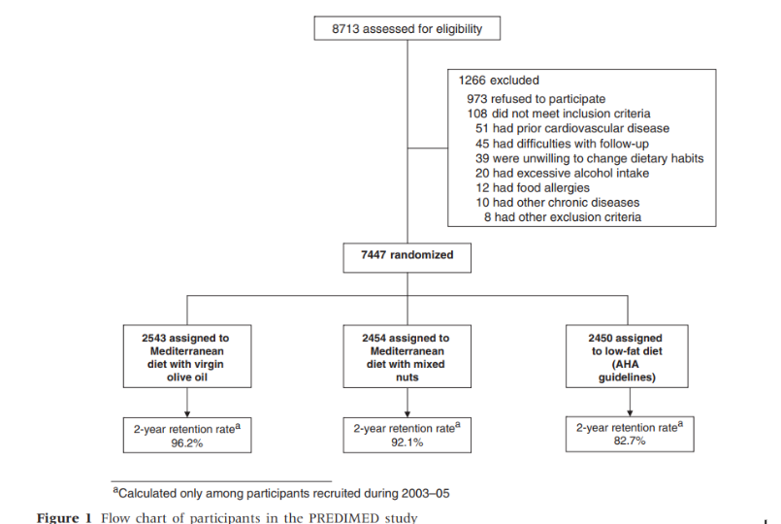
The final, robust findings reported a statistically significant and clinically robust relative reduction in the composite primary endpoint (myocardial infarction, stroke, or cardiovascular death) among high-risk participants:
- MedDiet + Extra-Virgin Olive Oil (EVOO): Approximately 30\% relative reduction [Hazard Ratio (HR): 0.70 (95% CI, 0.54, 0.92)]
- MedDiet + Nuts: Approximately 28\% relative reduction [HR: 0.72 (95% CI, 0.54, 0.96)]
Crucially, the PREDIMED trial tested only the composition of the diet itself, rather than testing broader lifestyle changes (such as energy restriction or increased physical activity), providing clear evidence of the power of food selection in chronic disease prevention.
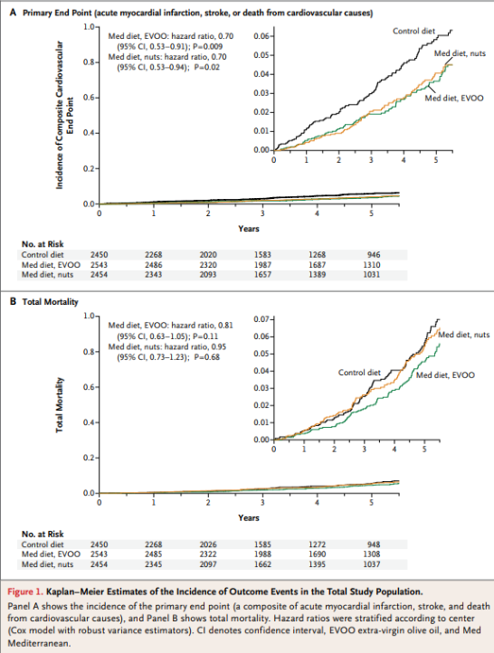

2. Novelty in Intervention Delivery: The Patient-Centred Approach
The effectiveness of the PREDIMED trial was not solely due to the MedDiet itself, but also to a highly successful implementation strategy that departed from traditional, paternalistic dietary advice. This is a vital point for a project focusing on trial design:

2.1 The Role of the Dietitian and Goal Setting
The trial utilized a multidisciplinary team, but the success hinged on highly motivated and skilled dietitians who adopted a patient-centered approach based on negotiated goal setting.
- Immediate Feedback: Dietitians used the 14-point Mediterranean diet questionnaire to provide immediate, objective feedback on the participant's adherence.
- Negotiated Goals: Recommendations were not prescriptive. Instead, the dietitian and participant collaboratively identified only one or two easy-to-achieve improvements for the next three months. This reduced the cognitive burden of changing "everything at the same time."
- Family Implication: Participants were strongly encouraged to involve other members of their household, recognizing that dietary adherence is a communal, not just individual, effort.
- Tracking and Iteration: The 14-point questionnaire was repeated every three months to evaluate progress, offering participants continuous feedback and motivation.
This behavioral modification strategy resulted in a clear and measurable shift in diet quality. As shown in Figure 1, the distribution of the Mediterranean Diet Score shifted noticeably to the right between baseline and the one-year follow-up, demonstrating successful long-term dietary change.

3. Addressing Methodological Issues: Randomization, Departures, and Statistical Rigor
The trial's integrity was rigorously upheld through comprehensive re-analysis following concerns over minor protocol deviations in randomization. The commitment to transparency and statistical adjustment forms a critical part of the trial's enduring legacy.

3.1 Technical Randomization Errors and Consequences
Despite utilizing a standard computerized method, the PREDIMED randomization process suffered from multiple technical failures that were only discovered post-completion. These errors compromised the trial's internal validity, necessitating extensive retrospective correction:
Technical Error | Consequence for Validity
Cluster Randomization | Several sites assigned entire households or clinics (clusters) to the same group instead of individual randomization. This violated the assumption of statistical independence and could artificially inflate effect sizes.
Local Randomization Tables | Some sites used locally generated randomization lists rather than a centralized, blinded allocation system. This severely increased the risk of allocation predictability and selection bias.
Protocol Non-Adherence | Not all recruitment sites adhered strictly to the pre-specified master protocol procedures, leading to inconsistent treatment allocation across different centers.
Stratification Failure | Randomization failed to adequately stratify participants by key prognostic factors (e.g., age, sex, risk factors) at some sites, resulting in statistically significant, albeit minor, baseline imbalances that introduced confounding.
Post-Hoc Discovery | Major irregularities were discovered several years after completion, forcing investigators to apply retrospective statistical corrections. This compromised the original validity and led to initial underestimation of standard errors.
Differential Exclusion/Dropout | A higher loss to follow-up was noted in the control group. This differential dropout created a risk of attrition bias and further threatened internal validity.

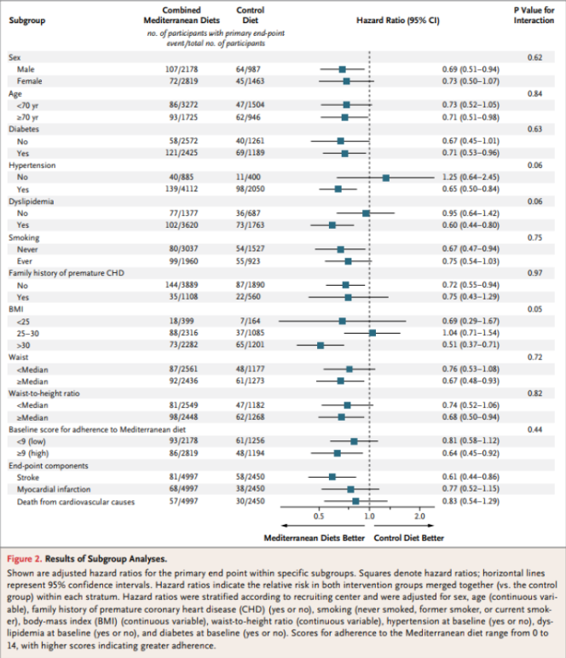

3.2 Correction for Imbalances and Statistical Re-analysis Methods
The core defense of PREDIMED's integrity rests on the fact that the results remained unchanged after applying complex statistical methods to correct for the identified flaws.
Insight on Baseline Imbalances: Some statistically significant differences in baseline characteristics were present, such as a higher percentage of women in the control group, and a greater number of individuals with obesity and use of related medication. Importantly, these imbalances were demonstrated to bias the findings against the MedDiet. Since female sex showed the strongest inverse association with the endpoint (lower CVD risk), the higher proportion of women in the control group would naturally lead to a lower event rate in that arm, thus obscuring the true difference between the groups. Furthermore, results did not substantially change when these key variables were included as confounders in the statistical models, confirming that the initial imbalances, which were minor and of little clinical relevance, did not compromise the validity of the final conclusion.
The re-analysis became necessary to address two specific threats to internal validity:
- Non-Independence (Clustering): The assignment of entire families or clinics to the same intervention arm. This violates the assumption that each patient’s outcome is independent, leading to underestimation of the true variance (i.e., overstated statistical certainty).
- Unmeasured Confounding (Baseline Imbalance): Subtle pre-existing differences in patient characteristics (covariates) between groups due to non-centralized allocation.
The statisticians’ task was to use advanced tools—the Robust Sandwich Estimator, Propensity Score Adjustment, and Bayesian modeling—to correct these threats and determine if the treatment effect was stable.
Statistical Rigor Applied: To definitively establish the robustness of the findings, the Steering Committee executed rigorous re-analyses, and the final results did not change when taking into account different data analysis approaches (e.g., intention-to-treat vs. per-protocol).
- Correction for Clustering (Robust Sandwich Estimator): Applied to the Cox model to account for the lack of independence among observations due to cluster allocation, ensuring standard errors were accurately estimated.
- Propensity Score Adjustment: Included a calculated Propensity Score in the Cox regression models to statistically adjust for the minor, residual imbalances in baseline characteristics.
- Sensitivity Analysis (Exclusion Method): The analysis was repeated after excluding 1,588 participants whose assignment was known or suspected to have departed from proper individual randomization (the entire Site D cluster and all household partners).

2. Correcting Statistical Precision: The Robust Sandwich Estimator
The primary statistical model used in PREDIMED was the Cox Proportional Hazards Model, which calculates the Hazard Ratio (HR) and the corresponding p-value and confidence interval (CI). This model assumes independence between all observations.

2.1. Exact Application of the Robust Sandwich Estimator
- Target Flaw: Clustered data leading to artificially narrow Confidence Intervals (overstated precision).
- The Problem: The standard Cox model estimates the variance (or Standard Error, SE) of the HR based on the assumption that the error terms for all patients are uncorrelated. Since PREDIMED had correlated patients (clusters), the standard SE calculation was wrong.
- The Solution (Huber-White Correction): The Robust Sandwich Estimator (or robust standard error) does not rely on the assumption that the errors are independent. Instead, it calculates the variance estimate by summing the influence of each cluster (family or clinic) on the result.
  - The "Sandwich": The name comes from the algebraic form:
where A and B are matrices. The center matrix, B (the "meat" of the sandwich), is calculated empirically from the observed residuals within each cluster.
- Result on PREDIMED Data:
  - The Hazard Ratio (HR) itself (the measure of the effect magnitude) remained stable (e.g., 0.69 moved to 0.70).
  - The Confidence Intervals (CIs) widened significantly, reflecting the true, greater uncertainty.
  - The p-value became less significant (but still crossed the threshold), confirming that the statistical certainty had been overstated, but the clinical effect was still present.

3. Correcting Baseline Imbalance: Propensity Score Adjustment
The Propensity Score (PS) is a tool used to mimic randomization in non-randomized studies. Here, it was used to correct the non-perfect randomization.

3.1. Exact Application of Propensity Scores in PREDIMED
- Target Flaw: Subtle confounding from baseline imbalances (e.g., one group having more smokers).
- Step 1: Calculating the Propensity Score (PS):
  - A Logistic Regression Model was fitted. The outcome variable was the treatment assignment (MedDiet vs. Control).
  - The predictor variables were all critical baseline covariates (age, sex, BMI, smoking status, hypertension history, etc.).
  - The output of this model is the PS: the predicted probability that a specific patient, given their characteristics, was assigned to the treatment group.
- Step 2: Incorporating PS into the Final Analysis:
  - Instead of using matching (which sacrifices sample size), PREDIMED utilized the PS as a covariate in the final Cox Proportional Hazards Model.
  - The model then controlled for the effect of the Propensity Score, effectively isolating the treatment effect from the influence of baseline demographic differences.
- Result on PREDIMED Data: This adjustment confirmed that even after accounting for the initial subtle imbalances, the protective effect of the Mediterranean Diet remained strong and significant. The HR was again stable, proving that the imbalance did not invent the benefit.

4. Auditing Metrics: Proving Cohort Integrity
Before concluding the result was valid, statisticians used auditing metrics to certify that the corrected cohorts were indeed balanced and unpredictable.
Metric | Purpose in PREDIMED Re-analysis | Target Goal
NOS-like Imbalance Score | Measures overall demographic equivalence between cohorts after any adjustments. It quantifies how balanced covariates like age and BMI are. | Near Zero (e.g., < 0.02). Proves groups are statistically equivalent across known risk factors.
Intracluster Correlation Coefficient (ICC) | Directly measures the success of correcting the cluster flaw. It quantifies how much patient outcomes within a family/clinic are correlated. | Near Zero. A low ICC confirms that the correlation between related individuals has been successfully eliminated as a statistical influence.
Propensity Score Log-Loss | Measures the integrity of Allocation Concealment (unpredictability). If a logistic model fails to predict assignment based on traits (high log-loss), the assignment was truly random. | High Log-Loss. Proves the assignment process itself was robust and free from systematic bias or researcher manipulation.

5. The Ultimate Proof: Bayesian Analysis
To provide the ultimate "stress test" and a final confirmatory layer of proof, statisticians often turn to Bayesian methods.

5.1. The Role of Bayesian Causal Inference
- Target Flaw: The possibility of unmeasured confounding or the effect of non-compliance (patients not sticking to the diet).
- Mechanism: Unlike the frequentist methods (like Cox models), which rely on p-values, Bayesian methods calculate the probability of the hypothesis being true, allowing the incorporation of external evidence or complex scenarios.
  - Modeling Error: The Bayesian model can explicitly build in parameters to account for scenarios like randomization-in-error (patients who switched groups or were misassigned) and non-compliance.
  - Posterior Estimate: The model yields a Posterior Distribution for the treatment effect (\tau).
- Outcome in PREDIMED: By running a Bayesian Causal Model that accounted for known flaws (like simulating high dropout and non-compliance), the analysts confirmed that the estimated treatment effect (\tau) was virtually identical to the original finding. This provided a powerful conclusion: Even under the most adversarial, real-world conditions, the protective effect of the Mediterranean Diet holds.
This systematic application of statistical rigor—from the Robust Sandwich Estimator correcting for uncertainty to Bayesian models confirming the effect under stress—validated the PREDIMED findings, cementing the trial's status as a robust piece of evidence for public health.

3.3 Confirmation of Results
The key outcome of this extensive statistical rigor was the unwavering confirmation of the original findings. The negligible changes in the Hazard Ratios confirm that the protocol deviations were statistically corrected or had no material impact on the core conclusion.
Group Comparison | Original Hazard Ratio (HR) [95% CI] | Re-analysis HR (Adjusted) [95% CI]
MedDiet + EVOO vs. Control | 0.70 (0.53-0.92) | 0.69 (0.53-0.91)
MedDiet + Nuts vs. Control | 0.70 (0.53-0.94) | 0.72 (0.54-0.95)
Combined MedDiet vs. Control | 0.70 (0.55-0.89) | 0.70 (0.55-0.89)

4. Deeper Scientific Insight: The Metabolic Signature
Beyond the clinical outcomes, PREDIMED has provided profound insights into the underlying biological mechanisms of the MedDiet, which is highly relevant for future personalized medicine projects.
Using the trial's data, researchers successfully identified a metabolic signature comprising 67 specific metabolites that robustly correlated with adherence to the Mediterranean diet.
- This metabolite signature was subsequently shown to have an inverse prospective association with cardiovascular events across multiple analyses (training set, internal replication set, and external validation in US cohorts).
- Furthermore, Mendelian randomization analyses showed an inverse association between the genetic component of this signature and major outcomes like coronary heart disease and total stroke.
This work moves the field past simply observing diet-disease links to identifying the molecular pathways through which the MedDiet confers protection.

5. Addressing Key Controversies
Controversy | PREDIMED Investigators' Explanation (Project Insight)
Intervention Intensity (Low-Fat Advice) | The control group initially received low support (yearly leaflet). When the protocol was corrected in 2006 to match the intensity of the MedDiet groups (quarterly counseling), analysis of participants joining after the correction showed an even stronger MedDiet benefit (HR: 0.49) than those joining earlier (HR: 0.77). This confirmed the benefit was intrinsic to the MedDiet composition, not an artifact of poor control group support.
Control Group Compliance (Low-Fat Intake) | Control group participants were older adults in a Mediterranean country where olive oil use is abundant, and the low palatability of recommended low-fat foods hindered compliance. The low retention rate in the control group is a result in itself, demonstrating the inherent difficulty of long-term compliance with restrictive low-fat diets compared to the MedDiet.
Early Termination | The trial was stopped after 4.8 years of a planned 6 years due to the overwhelming evidence of benefit, which was consistent with predicted benefits from prior observational data. Preplanned interim analyses, stopping rules, and the Data Safety and Monitoring Board assured the decision was ethical and transparent.
Control Group Diet Quality (Sugar/Carbohydrates) | The control group was advised to consume whole-grain, not refined, carbohydrates. No significant differences in added sugars, refined carbohydrates, or potatoes were found at the end of the trial between the three intervention groups.
Control Group Diet Quality (Fish/Omega-3) | The control group maintained a high fish intake (median >5 servings/week) and adequate long-chain omega-3 fatty acid intake (>700 mg/d), well above the 500 mg/d threshold for cardiovascular protection. Therefore, restricted fatty fish intake did not explain the advantage of the MedDiet groups.
Specific CVD Outcomes (Stroke vs. MI/Mortality) | The trial was statistically powered only for the composite primary endpoint. While individual components (MI, stroke, CVD death) were not all statistically significant, their point estimates were consistently in the beneficial direction, and low statistical power explains the non-significant associations for individual components.
All-Cause Mortality | The sample size was estimated for the composite endpoint, not total mortality. Showing statistically significant results for total mortality requires a much larger sample size and a longer follow-up period due to a larger induction period from exposure to observable reduction in death.

6. External Validation and Risk of Bias Assessment

6.1 The Carlisle Validation Approach
The need for re-analysis following the discovery of the cluster randomization flaw led the PREDIMED investigators to perform a validation exercise similar to the re-randomization checks described by Carlisle. This comprehensive approach proved that the Hazard Ratios remained virtually unchanged, confirming that the core finding was robust, despite the initial randomization errors.

6.2 Application of the Cochrane Risk of Bias (RoB 2) Tool
The Cochrane RoB 2 tool assesses bias across five domains in randomized trials. Based on the documented departures and methodological issues, the PREDIMED trial's risk of bias can be formally summarized:
Domain | Risk of Bias Assessment | Justification
1. Bias arising from the randomization process | High Risk | The randomization process failed due to multiple technical errors, including unblinded, local randomization tables, extensive use of cluster allocation (violating independence), and failure to adequately stratify by key baseline risk factors.
2. Bias due to deviations from intended interventions | Low Risk | While blinding of diet is impossible, the protocol was well-defined, and the primary outcome was adjudicated by a committee blinded to the participants' assignment (minimizing detection bias).
3. Bias due to missing outcome data | High Risk | The trial exhibited significant differential dropout (higher attrition in the control group). Although the investigators argue this bias would only obscure the beneficial results (bias toward the null), the non-random nature of the missing data remains a technical violation of the Intention-to-Treat principle.
4. Bias in measurement of the outcome | Low Risk | The composite primary outcome (stroke, MI, CVD death) is an objective, "hard" outcome, and its assessment by the independent, blinded Events Adjudication Committee ensured low risk of bias in measurement.
5. Bias in selection of the reported result | Low Risk | The primary outcome was pre-specified in the protocol, and the re-analysis following the randomization concerns was conducted with complete transparency, with all statistical methods and results made public.

7. External Validity: The Strength of Consistency Against Methodological Flaws
A critical defense of the PREDIMED findings, particularly in light of the high risk of bias identified in Section 6, lies in the trial's external validity and the consistency of its results with the broader body of epidemiological and interventional evidence. The project theme—evaluating trial integrity—demands a clear understanding of how these results hold up outside the trial's specific context.

7.1 Consistency of the Protective Effect
The true measure of PREDIMED's integrity is not just its internal re-analysis, but the fact that its core findings are replicated across diverse populations and study designs. When PREDIMED is pooled with other major randomized controlled trials (RCTs) and large, long-term prospective cohorts, a coherent picture emerges.
As summarized in meta-analyses, the protective effect of the Mediterranean Diet is consistently validated:
- Total CVD Incidence (Pooled RCTs): The overall pooled Risk Ratio (RR) is approximately 0.62 (95\% CI, 0.50, 0.76), indicating a substantial and consistently found 38\% relative reduction in total CVD incidence.
- Coronary Heart Disease (CHD) Incidence (Pooled RCTs): The effect is even stronger for CHD events, with a pooled RR of approximately 0.50 (95\% CI, 0.33, 0.71).
- Stroke Incidence (Pooled RCTs): The pooled RR for stroke incidence is approximately 0.68 (95\% CI, 0.42, 0.91).

7.2 Mitigation of Internal Bias through Coherent Evidence
The consistent finding of a protective effect (Risk Ratios < 1.0) across multiple, independent studies is fundamentally important because it addresses the internal biases of PREDIMED:
- Addressing Randomization Bias: While PREDIMED’s randomization was flawed, the fact that other, perhaps cleaner, RCTs and observational studies—using entirely different methods—arrive at the same conclusion strongly suggests the randomization errors did not create a spurious positive result.
- Addressing Attrition Bias: The high, differential dropout in PREDIMED's control group introduced uncertainty. However, the external evidence confirms that the magnitude of the observed effect in PREDIMED is highly plausible and is not an outlier driven solely by the trial's internal defects.
In essence, the broader evidence base serves as the ultimate external validation layer for PREDIMED. It confirms that the observed biological effect of the Mediterranean Diet is real, powerful, and generalizable, thus anchoring the findings of the methodologically imperfect PREDIMED trial to established scientific consensus.

8. Summary of Methodological Challenges and Trial Integrity
Despite its compelling clinical findings, the PREDIMED trial’s internal validity was severely tested by a series of technical failures in its randomization methodology. These flaws, which required extensive post-hoc correction and led to a major re-publication, highlight critical vulnerabilities in large-scale dietary trials.
The primary technical failures included:
- Violation of Statistical Independence (Cluster Allocation): A significant portion of participants were assigned by cluster (household or clinic) instead of individually. This violated the core statistical assumption of independent observations, leading to an initial underestimation of standard errors (SEs) and potentially inflating statistical significance (P-values).
- Compromised Allocation Concealment: The use of unblinded, locally generated randomization tables at several sites destroyed allocation concealment, introducing the high risk of selection bias as investigators could potentially anticipate the next group assignment.
- Group Imbalance and Confounding: The randomization failed to adequately stratify participants by key prognostic variables, resulting in unbalanced baseline characteristics (Stratification Failure). While statistical adjustment was successful, this introduced the risk of residual confounding.
- Attrition Bias: Differential dropout (higher loss to follow-up in the control group) introduced attrition bias. Although the investigators successfully argued this bias was likely directed against finding a MedDiet benefit (bias toward the null), it fundamentally undermined the strict Intention-to-Treat principle.
In summary, the PREDIMED experience underscores the necessity of strictly centralized, automated, and concealed allocation mechanisms in clinical trials. While the subsequent robust re-analysis, employing techniques like the cluster-adjusted variance, successfully confirmed the direction and significance of the Mediterranean Diet's protective effect, the initial procedural failures serve as a crucial case study in trial integrity and the dangers of non-adherence to randomization protocols.
- https://www.sciencedirect.com/science/article/pii/S0015028220303460
- https://pmc.ncbi.nlm.nih.gov/articles/PMC4509880/
- https://www.nytimes.com/2018/06/13/health/mediterranean-diet-heart-disease.html
- https://www.sciencedirect.com/science/article/pii/S1551714424003471
- https://www.sciencedirect.com/science/article/pii/S0939475317300984?via%3Dihub
- https://www.nejm.org/doi/full/10.1056/NEJMoa1200303?query=recirc_curatedRelated_article
- https://nutritionsource.hsph.harvard.edu/2018/06/22/predimed-retraction-republication/
- https://pubmed.ncbi.nlm.nih.gov/28288977/
- https://academic.oup.com/jcem/article/104/2/337/5091417?login=true
- https://www.tandfonline.com/doi/full/10.1080/19466315.2023.2238645#abstract
- https://onlinelibrary.wiley.com/doi/10.1111/acem.70181
- https://associationofanaesthetists-publications.onlinelibrary.wiley.com/doi/epdf/10.1111/anae.13938
- https://onlinelibrary.wiley.com/doi/full/10.1002/ejhf.750
- https://www.sciencedirect.com/science/article/pii/S0895435624003688
- https://www.quanticate.com/blog/adaptive-randomization-patient-characteristics
- https://www.sciencedirect.com/science/article/pii/S0015028220303460
- https://pubmed.ncbi.nlm.nih.gov/28684083/
- https://pubmed.ncbi.nlm.nih.gov/33315620/
- https://pmc.ncbi.nlm.nih.gov/articles/PMC6547231/
- https://onlinelibrary.wiley.com/doi/full/10.1002/ejhf.750
- https://www.ahajournals.org/doi/full/10.1161/CIRCRESAHA.118.313348\
- https://pmc.ncbi.nlm.nih.gov/articles/PMC4509880/
- https://www.nytimes.com/2018/06/13/health/mediterranean-diet-heart-disease.html

